**Calculator Assumed**

**Mixed Counting and Probability**

Time: 45 minutes

Total Marks: 45

Your Score: / 45



**Question One: [5 marks]**

Five hundred people were surveyed on how they preferred to access daily news. Four hundred people preferred to watch the news on TV while only 20 accessed news exclusively by reading the newspaper.

Only two people did not access news daily and 320 people accessed the news through TV, newspaper and online.

The number of people who accessed news through exactly two of the three categories was 20 for each of the three combinations.

Use this information to complete the Venn diagram below.

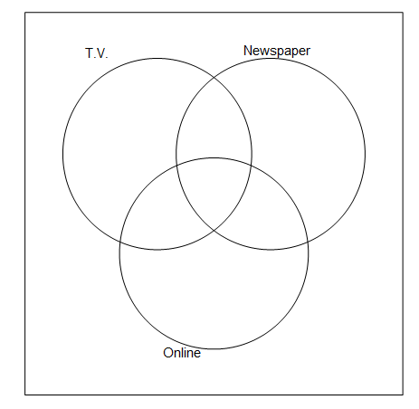

**Question Two: [4, 2 = 6 marks]**

Events A and B are such that  and .

1. Use the above information to create a two-way table in the space below.
2. Determine 

**Question Three: [4 marks]**

Use your calculator to determine the first, second, fifth and middle terms in the 25th row of Pascal’s Triangle.

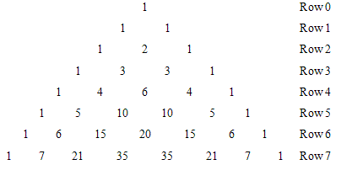

**Question Four: [1, 2, 2, 2, 3 = 10 marks]**

People were surveyed on their preferred social media platform and the results are tabulated below.

|  |  |  |  |  |  |
| --- | --- | --- | --- | --- | --- |
|  | Facebook | Twitter | Instagram | SnapChat | Total |
| 13 – 17 years | 30 | 3 | 22 | 65 | 120 |
| 18 – 22 years | 20 | 8 | 62 | 30 | 120 |
| 23 – 30 years | 30 | 35 | 45 | 10 | 120 |
| Above 30 years | 75 | 40 | 5 | 0 | 120 |
| Total | 155 | 86 | 134 | 105 | 480 |

Base your following responses on the data collected.

1. Which platform was the most popular?
2. Instagram and SnapChat are platforms that almost exclusively rely on sharing photos. Comment on their popularity.
3. In a group of 1000 people aged above 30 years, how many can you expect to prefer Instagram?
4. Of those who prefer Twitter, how likely are they to be in the 23-30 years age group?
5. The Marketing department at Facebook are interested in interviewing 2 people from each of the four age groups given. If they choose candidates to interview at random, how many choices do they have in total?

**Question Five: [4 marks]**

Mr and Mrs Brangelina have always wanted identical twins. So far they have two children. The chance of identical twins is 1 in every 285 pregnancies.

Given that their first child is a boy, what is the probability that their second child is a girl and their third pregnancy results in identical twins?

**Question Six: [3, 6 = 9 marks]**

A game involves rolling a standard 6 sided dice and randomly selecting a card from a deck of 8 cards, each imprinted with one of the first eight even numbers. The result from the dice and the card are then added together.

1. Draw a suitable sample space which illustrates all possibilities.
2. Calculate the probability:

(i) that a 4 was rolled on the dice.

(ii) of obtaining an odd sum.

(iii) of obtaining a sum greater than 16 given that the dice rolled a 4.

(iv) of a 5 being rolled or obtaining a sum less than 16.

**Question Seven: [1, 6 = 7 marks]**

Joan is interested in making codes used to secretly encode information written in English. Before she can start her code she needs to choose what to replace the letters of the English alphabet with.

For her latest code she decides to encode each of the vowels in the following way:

Letter A will be represented by a two digit number

Letter E will be made up of a digit followed by a consonant

Letter I will be made up of 1 of the following Greek letters: Ψ, Π, Σ, Φ, in any order

Letter O will be made up of 1 of the remaining Greek letters used for I.

Letter U will be made up of 3 of the following symbols: %, $, &, @, *, #, none being used more than once, and where the order is not important.

1. How many ways can the letter O be encoded?
2. How many ways in total are there of encoding all five vowels?

**SOLUTIONS**

**Calculator Assumed**

**Mixed Counting and Probability**

Time: 45 minutes

Total Marks: 45

Your Score: / 45



**Question One: [5 marks]**

Five hundred people were surveyed on how they preferred to access daily news. Four hundred people preferred to watch the news on TV while only 20 accessed news exclusively by reading the newspaper.

Only two people did not access news daily and 320 people accessed the news through TV, newspaper and online.

The number of people who accessed news through exactly two of the three categories was 20 for each of the three combinations.

Use this information to complete the Venn diagram below.

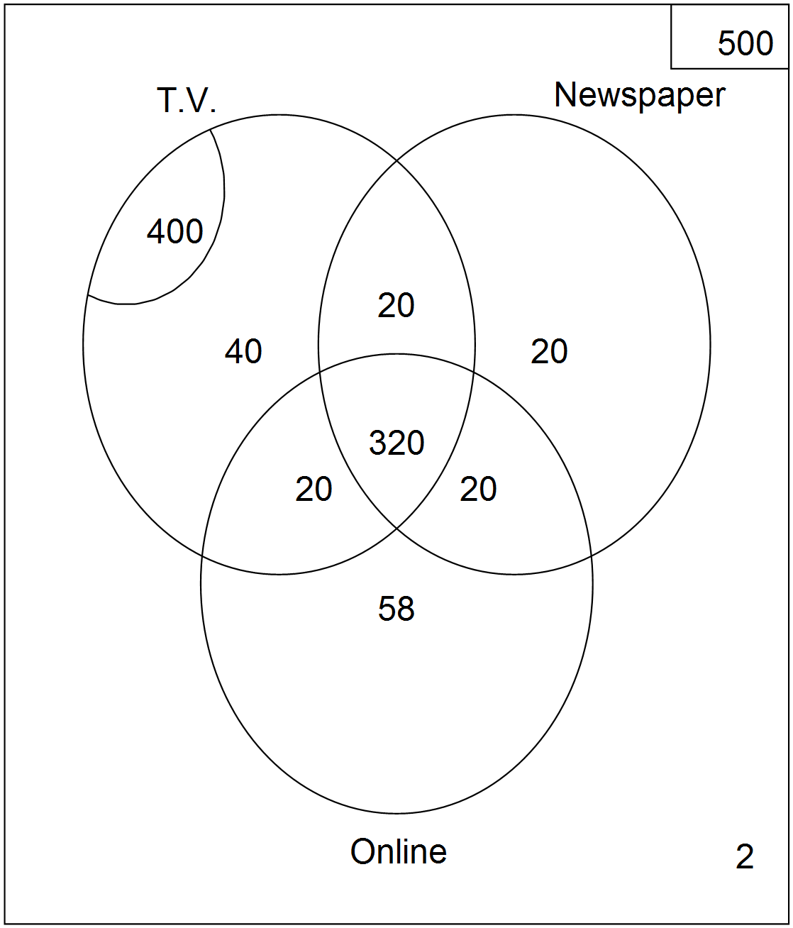

**Question Two: [4, 2 = 6 marks]**

Events A and B are such that  and .

1. Use the above information to create a two-way table in the space below.

|  |  |  |  |
| --- | --- | --- | --- |
|  |  |  |  |
|  | 0.3 | 0.2 | 0.5 |
|  | 0.3 | 0.2 | 0.5 |
|  | 0.6 | 0.4 | 1 |



1. Determine 



**Question Three: [4 marks]**

Use your calculator to determine the first, second, fifth and middle terms in the 25th row of Pascal’s Triangle.



First = 1

Second = 25

Fifth = 12650

Middle two terms = 5 200 300

**Question Four: [1, 2, 2, 2, 3 = 10 marks]**

People were surveyed on their preferred social media platform and the results are tabulated below.

|  |  |  |  |  |  |
| --- | --- | --- | --- | --- | --- |
|  | Facebook | Twitter | Instagram | SnapChat | Total |
| 13 – 17 years | 30 | 3 | 22 | 65 | 120 |
| 18 – 22 years | 20 | 8 | 62 | 30 | 120 |
| 23 – 30 years | 30 | 35 | 45 | 10 | 120 |
| Above 30 years | 75 | 40 | 5 | 0 | 120 |
| Total | 155 | 86 | 134 | 105 | 480 |

Base your following responses on the data collected.

1. Which platform was the most popular?



Facebook

1. Instagram and SnapChat are platforms that almost exclusively rely on sharing photos. Comment on their popularity.

Combined they have 0.498 of the audience so they are quite popular. They are most popular with younger users.



1. In a group of 1000 people aged above 30 years, how many can you expect to prefer Instagram?

 Therefore about 10 people

1. Of those who prefer Twitter, how likely are they to be in the 23-30 years age group?





1. The Marketing department at Facebook are interested in interviewing 2 people from each of the four age groups given. If they choose candidates to interview at random, how many choices do they have in total?





**Question Five: [4 marks]**

Mr and Mrs Brangelina have always wanted identical twins. So far they have two children. The chance of identical twins is 1 in every 285 pregnancies.

Given that their first child is a boy, what is the probability that their second child is a girl and their third pregnancy results in identical twins?





**Question Six: [3, 6 = 9 marks]**

A game involves rolling a standard 6 sided dice and randomly selecting a card from a deck of 8 cards, each imprinted with one of the first eight even numbers. The result from the dice and the card are then added together.

1. Draw a suitable sample space which illustrates all possibilities.



|  |  |  |  |  |  |  |  |  |
| --- | --- | --- | --- | --- | --- | --- | --- | --- |
|  | **2** | **4** | **6** | **8** | **10** | **12** | **14** | **16** |
| **1** | 3 | 5 | 7 | 9 | 11 | 13 | 15 | 17 |
| **2** | 4 | 6 | 8 | 10 | 12 | 14 | 16 | 18 |
| **3** | 5 | 7 | 9 | 11 | 13 | 15 | 17 | 19 |
| **4** | 6 | 8 | 10 | 12 | 14 | 16 | 18 | 20 |
| **5** | 7 | 9 | 11 | 13 | 15 | 17 | 19 | 21 |
| **6** | 8 | 10 | 12 | 14 | 16 | 18 | 20 | 22 |



1. Calculate the probability:

(i) that a 4 was rolled on the dice.

 

(ii) of obtaining an odd sum.

 

(iii) of obtaining a sum greater than 16 given that the dice rolled a 4.



 

(iv) of a 5 being rolled or obtaining a sum less than 16.





**Question Seven: [1, 6 = 7 marks]**

Joan is interested in making codes used to secretly encode information written in English. Before she can start her code she needs to choose what to replace the letters of the English alphabet with.

For her latest code she decides to encode each of the vowels in the following way:

Letter A will be represented by a two digit number

Letter E will be made up of a digit followed by a consonant

Letter I will be made up of 1 of the following Greek letters: Ψ, Π, Σ, Φ, in any order

Letter O will be made up of 1 of the remaining Greek letters used for I.

Letter U will be made up of 3 of the following symbols: %, $, &, @, *, #, none being used more than once, and where the order is not important.

1. How many ways can the letter O be encoded?





1. How many ways in total are there of encoding all five vowels?



 